**Class Tasks**

**Task#1:**

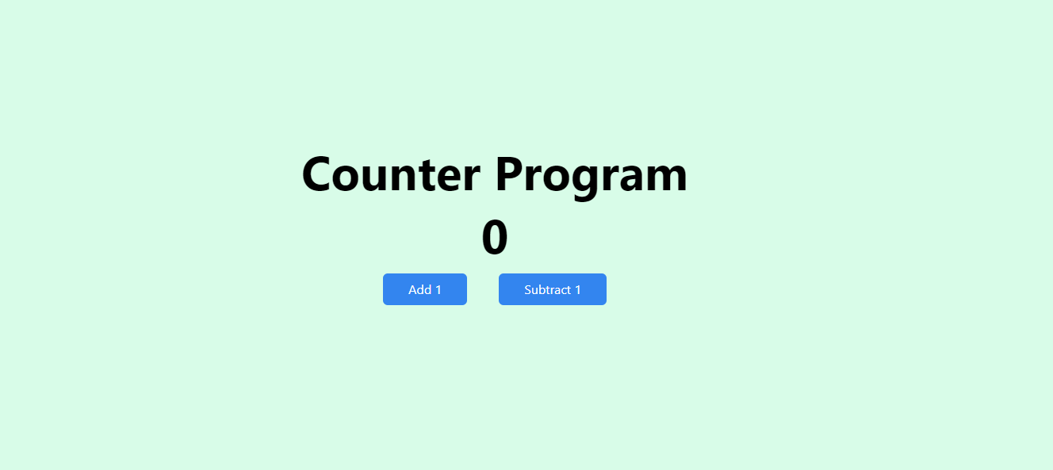

**Task#2**

**Create the following webpages using next js and tailwind css. The data is coming from the given file (i.e not static data)**

